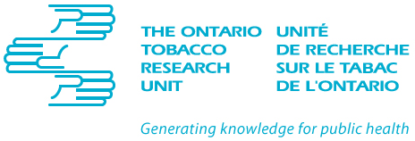

Ashley Studentships for Research in Tobacco Control

Studentship Deliverable Form

Please complete this form by October 31, 2012, if the start date chosen is May 1, or by February 28, 2013 if the start-date chosen is September 1 and return to:

Sandra Caswell
Project Coordinator
Ontario Tobacco Research Unit
33 Russell St.
Toronto, ON
M5S 2S1
416-595-8501 ext 4642
sandra_caswell@camh.net

Name of Awardee:

Term and year reporting on: ☐May 1 – August 31, 2012
☐ September 1 – December 31, 2012

- Research Results:

  - Please provide a short introduction to your research project including your rationale and objectives (200 word max.).

- Please describe the methodologies used for data collection and analysis (300 words max.).

- Please outline your research findings and lessons learned (500 words max.).

- Scholarly Activities:

  - Please list all conference and other presentations you have been involved in related to this award. For each, please provide author(s), title of presentation, name of conference/venue, location, date, and type of presentation (e.g. oral, poster).

  - Please list all published articles, abstracts and reports, as well as those in preparation or under review as a result of this award. Where relevant, please provide author(s), title, source, volume, issue, page numbers, and date (or in press).

- Concurrent Funding:

  - Please list any additional awards/funding held during the term of your Ashley Studentship. For each award, please provide the name of the award, granting agency/institution, funding period and amount of award.

Signature of Awardee: ___________________________ Date: ___________________________

Signature of Supervisor: _________________________ Date: ___________________________

